Approach to resolving problem scenarios

The following is a documentation of all the issues that have been identified in Openfabric testnet and what measures can be taken to possibly resolve them.

NOTE : These issues are in sequence with reference to the Bug Report Document.

Issue 1 : Text inside "Prompt"

Detailed description : Text entered inside prompt is removed when user click on “eye” icon button while customizing display

Screenshots:

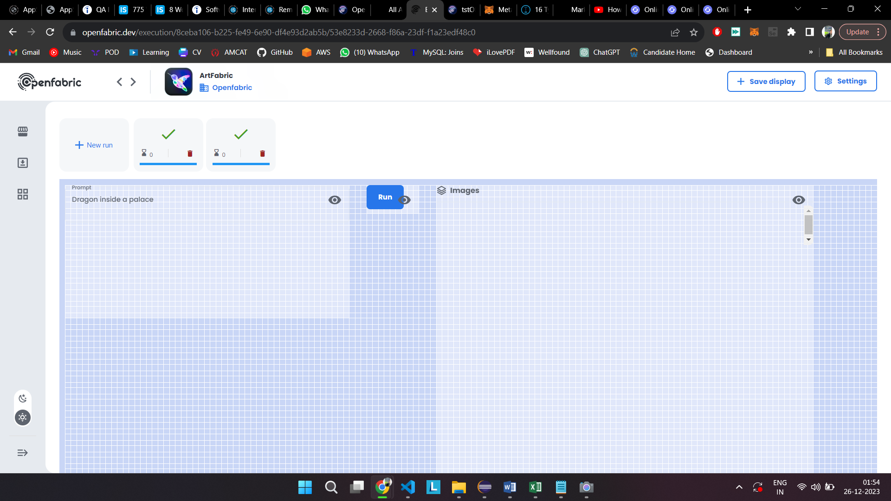

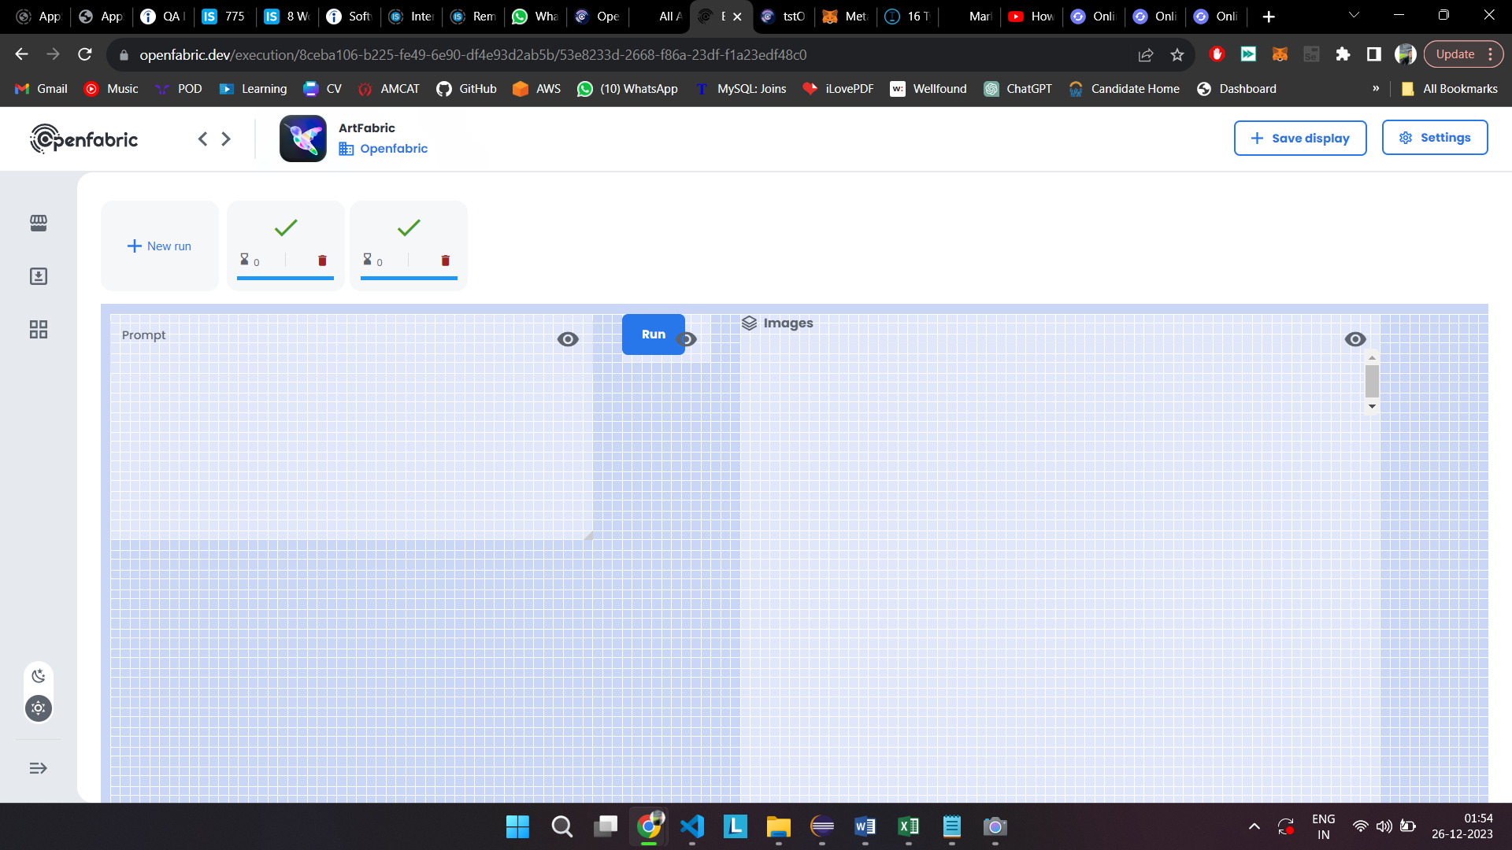

Possible Solution: A static text box can be added where the text remains even after customizing the buttons

Issue 2 : "Customize Display" Button

Detailed description : When users customizes page layout using settings, the page gets stuck in loading

Screenshots:

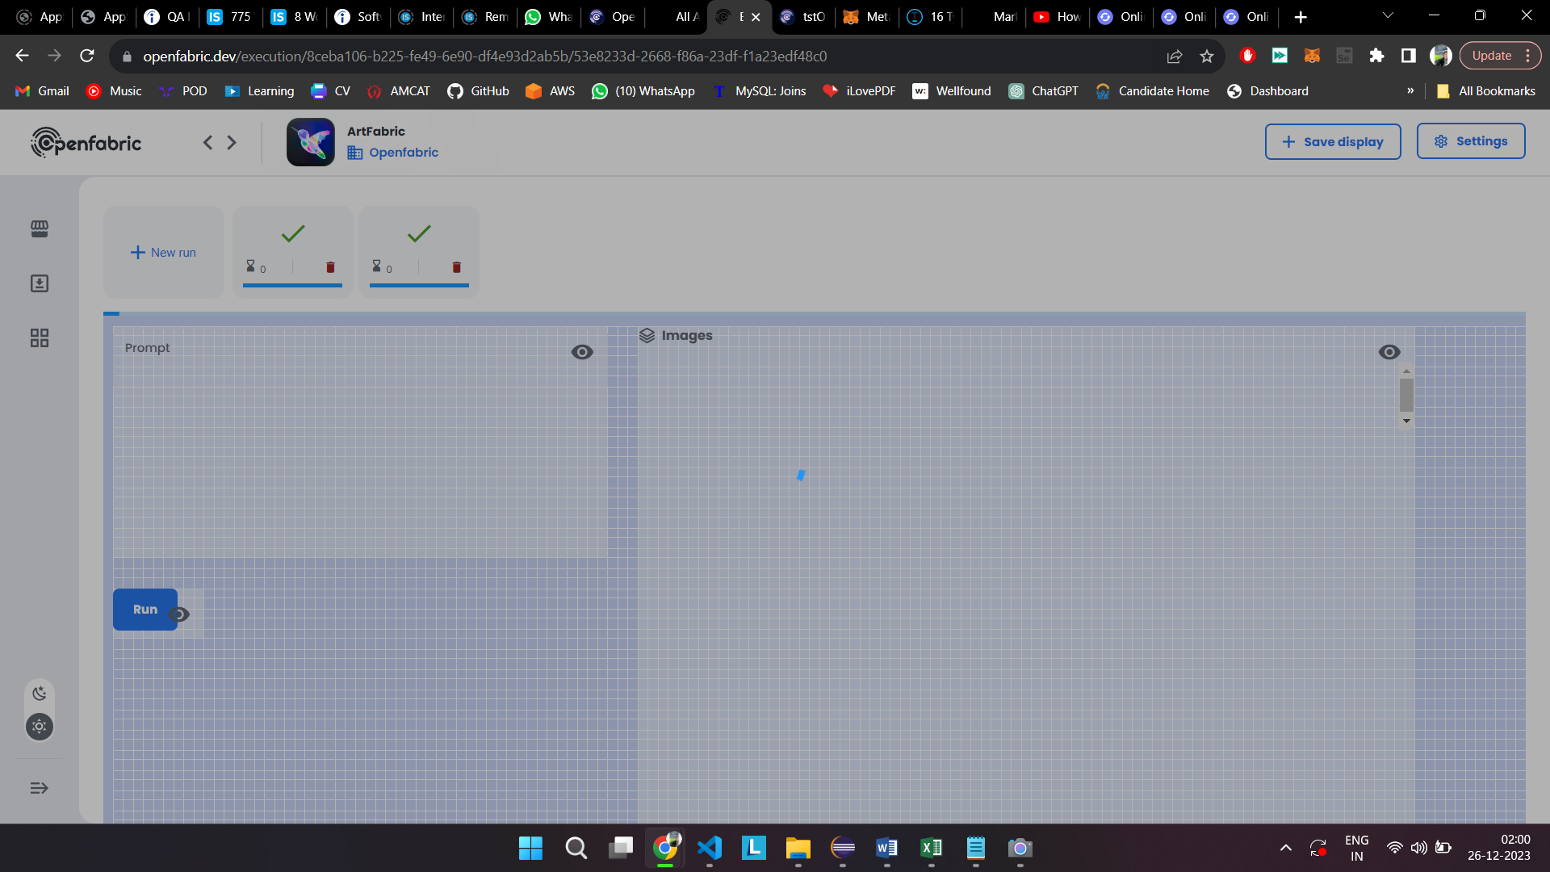

Issue 3 : "Reset Display" Button

Detailed description : After extracting an image inside Artfabric, when we click on Reset display button inside settings, multiple scroll bars appear at the right hand side of the image

Screenshots:

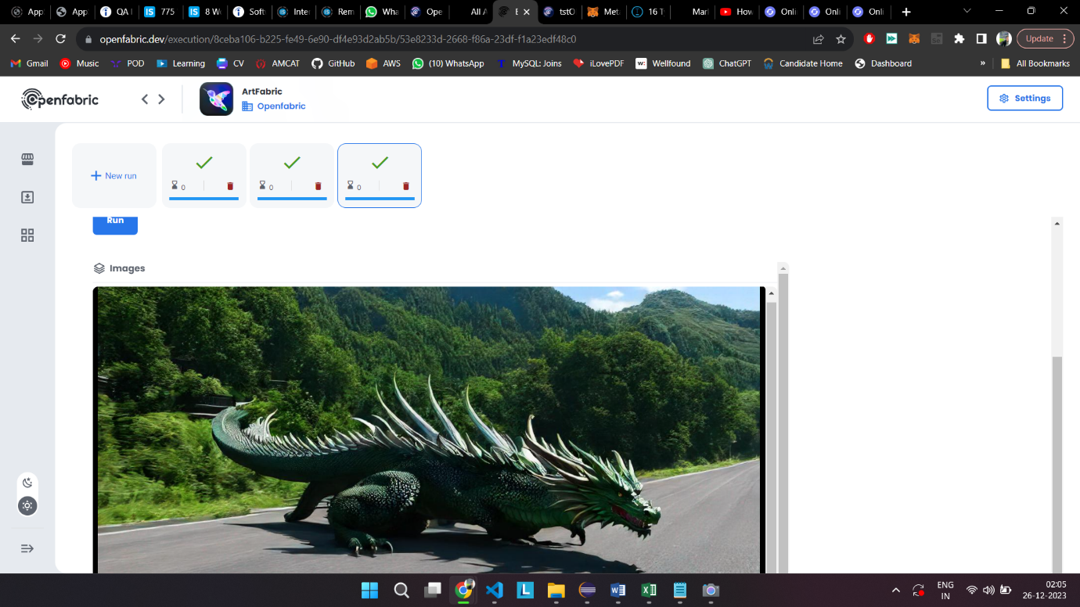

Possible Solution : An image viewer can be added inside where the image either opens in a new window or in a pop-up style view, same as windows photo viewer

Issue 4 : "Download" button for image

Detailed description : When sidebar menu is expanded, the image download button gets cropped out on display

Screenshots:

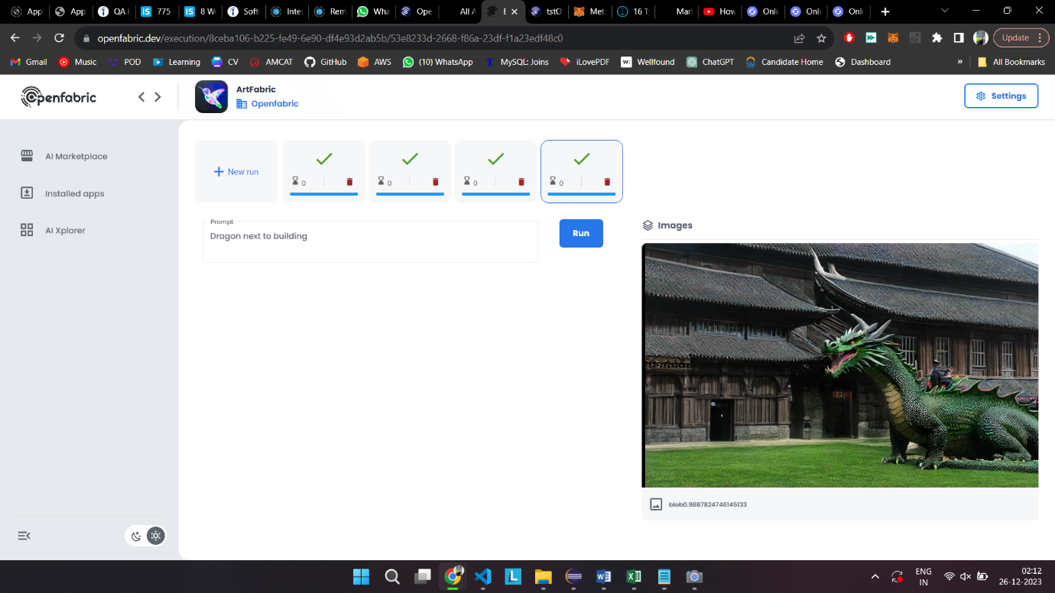

Possible Solution : Re-position the download button next to the “Images” text above the image

Issue 5 : Scroll bar for image

Detailed description : When sidebar menu is expanded, the image scrollbar gets cropped out on display

Screenshots:



Issue 6 : Scroll bar for prompt

Detailed description : If a description of more than 15 lines is entered inside prompt of Artfabric then then first line of the description is not visible

Screenshots:

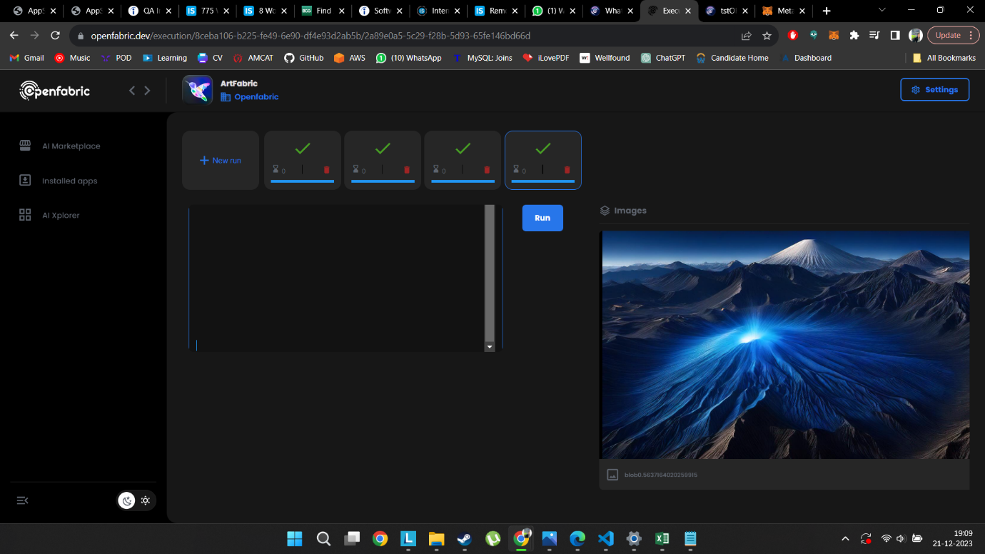

Issue 7 : "New run" button

Detailed description : The “+ New Run” button of QRFabric does not create more windows therefore, it does not work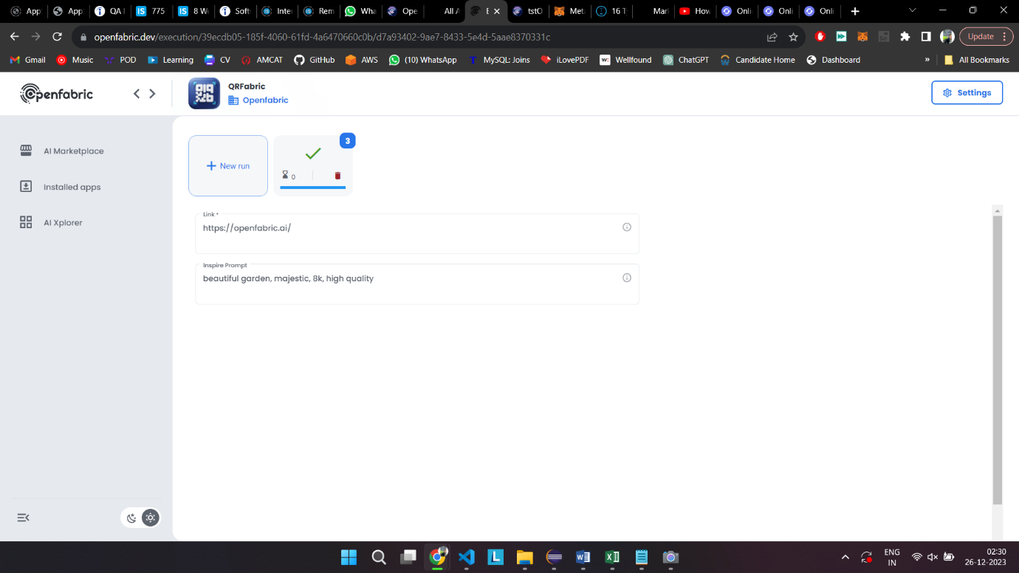  
Screenshots:

Issue 8 : "Run" button

Detailed Description : Run button is not visible upon vising the QRFabric app

Screenshots:



Issue 9 : "Help Center"

Detailed description : Upon clicking on “Help Center” at the bottom right corner of the page from any page, User is redirected to new tab of AI Marketplace page instead on Help Center

Screenshots:

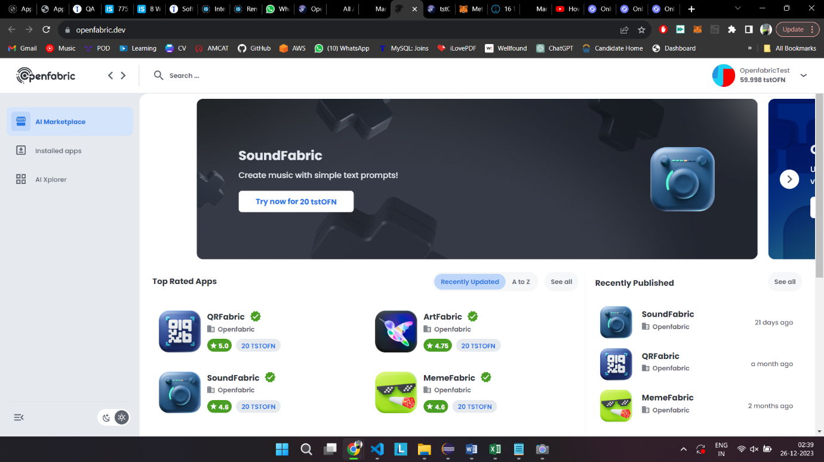

Possible Solution : User should get redirected to the Help Center page on a new tab

Issue 10 : "tstOFN" Balance not updating

Detailed description : After performing a transaction when we buy a new app, the tstOFN balance is not updated in real-time. Changes only take place once user refreshes the webpage.

Screenshots:

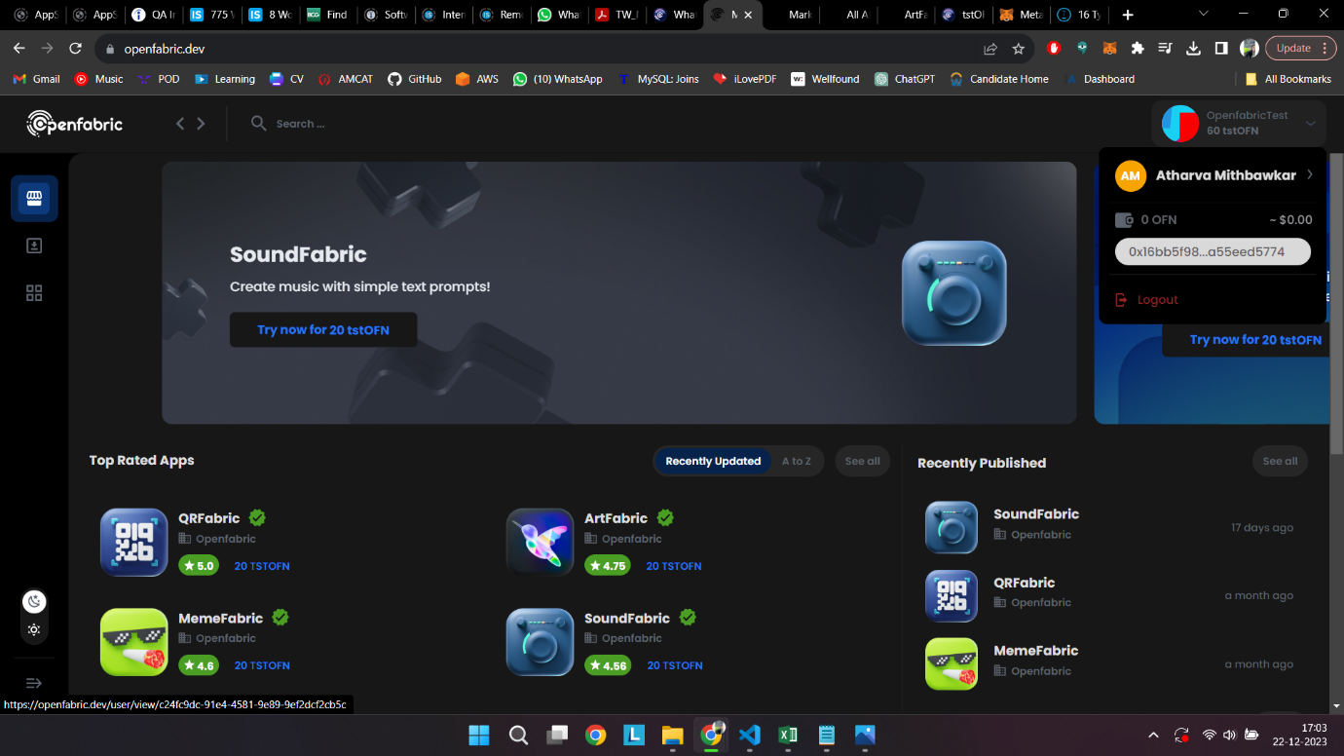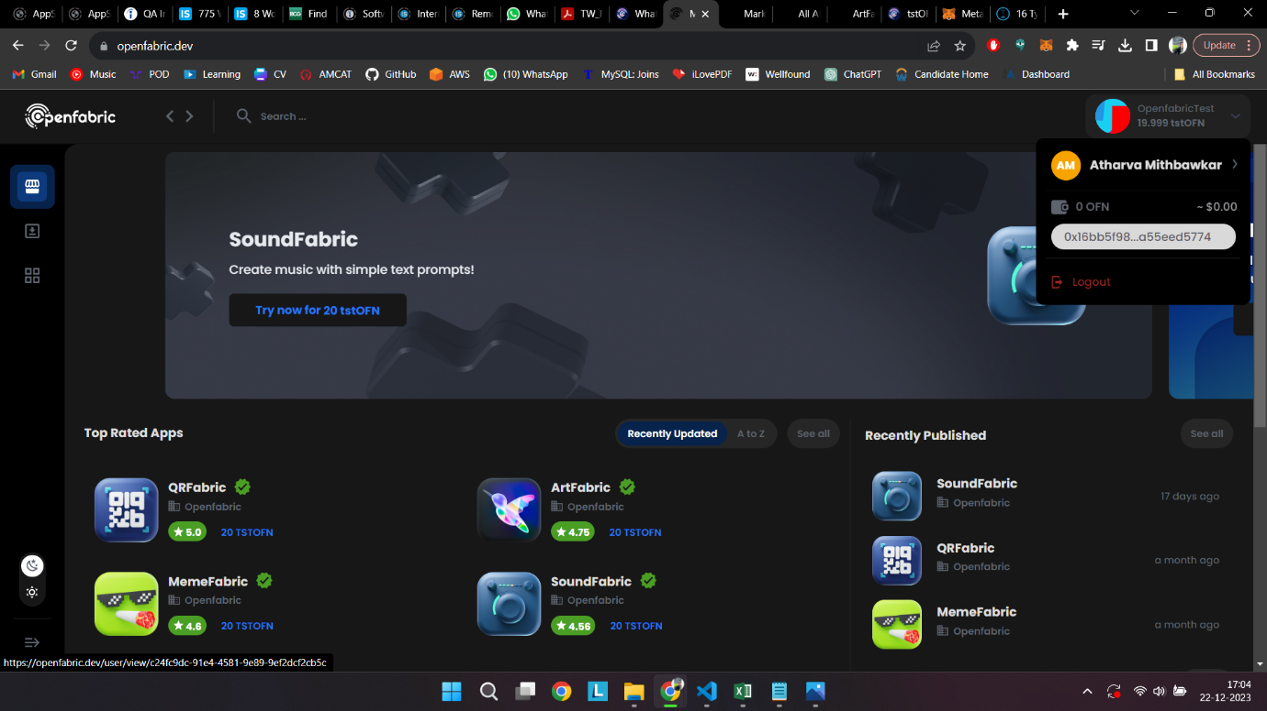

Possible Solution : The displaying tstOFN balance can be made dynamic so that it updates in real time

Issue 11 : Dark mode visibility issue

Detailed description : After adding a label to an app inside “Instances” when we switch to dark mode, The label is not properly visible

Screenshots:

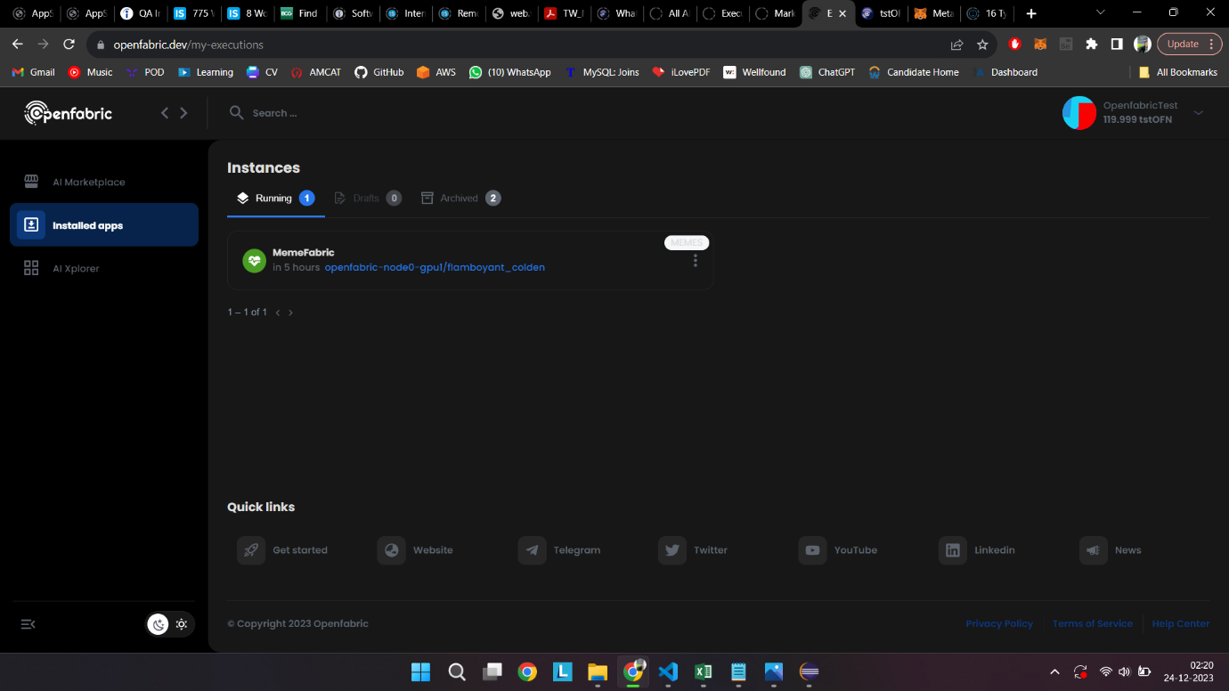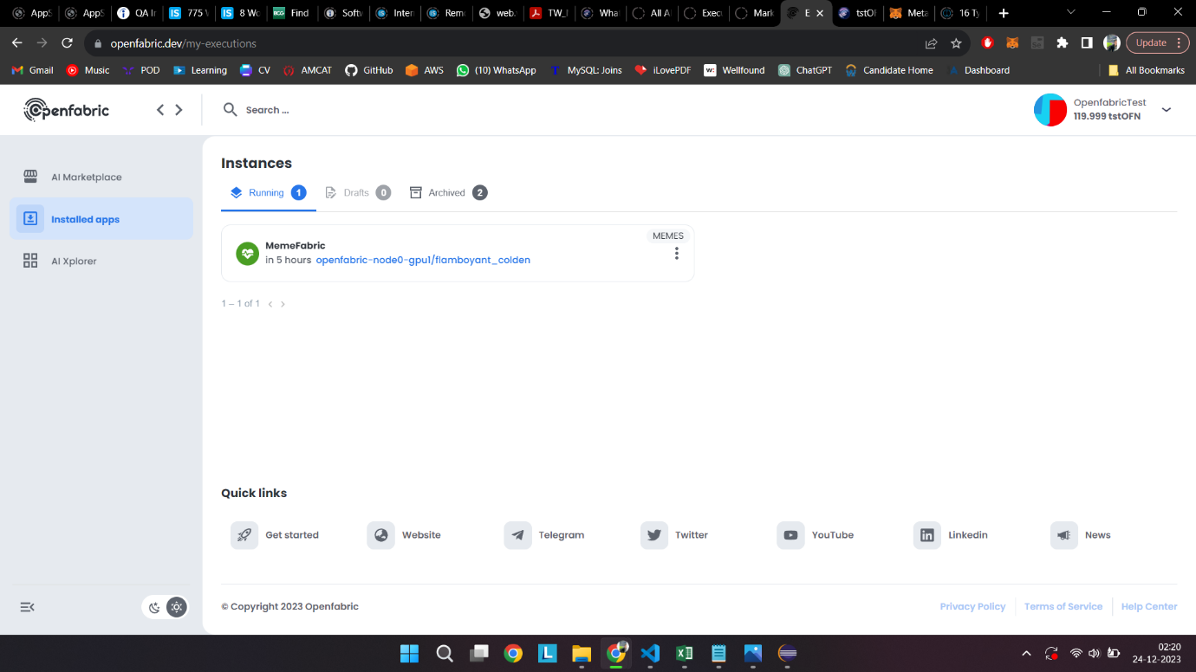

Possible Solution : The label badge can be provided with design properties that switch colours when user switches between Light/Dark modes

Issue 12 : "Archived" Apps

Detailed description : After user clicks on an instance from inside “Archived” under “Installed Apps”, Only the app name is displayed and the remaining page is blank

Screenshots:

